**15-puzzle game**

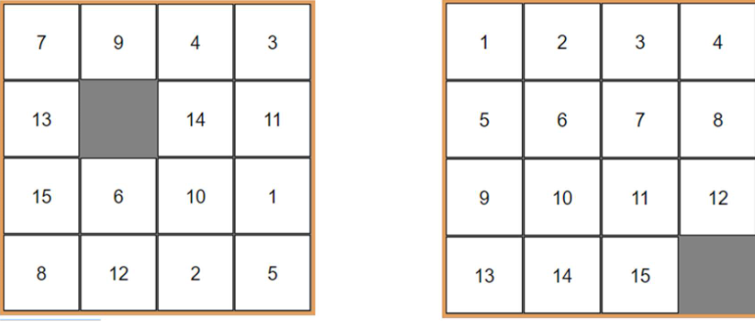

Can you get from the left state to the right by sliding the pieces?

Given an initial state inversion number = 67, row index of X = 1

Goal state inversion number = 0, row index of X = 3

It is solvable if and only if parities of inversion number + row index of X of the two states are the same

Inversion number: number of inversion pairs (e., a>b) of row-major ordering

**8-puzzle game**

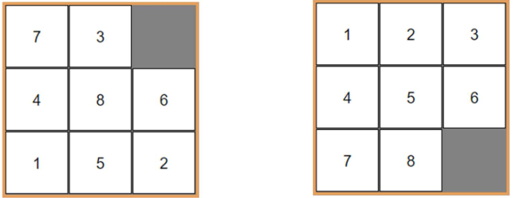

There is a solution if parities of inversion number of the two states are the same

**8-puzzle solver and implementation**

* Design and implement an 8-puzzle solver program, which takes initial and goal states, and output step-by-step solution if a solution exists
* To do list:
  + State and transfer representations
  + Is_valid(state) checks state validation
  + Inversion_number(state) calculates the inversion
  + Is_solvable(start, goal)
  + Solve(start,goal) returns the steps of moves to solve the puzzle

**How to present a state**

* Problem modeling
  + Graph model of 8-puzzle problem: states as nodes, transfer from one state to another as an edge
* Graph data structure design
  + State: int a[9] or int a[3][3]
  + Store integers 0 to 8, 0 as the empty

Typedef struct state{

Int a[9];

} state;

Void display_state(state *s){

Int I,j,*p = s->a

For(I =0;i<3;i++){

For(j=0;j<3;j++) printf(“%d”,*p++);

Printf(“\n”);

}

Printf(“\n”);

}

Int is_valid(state *s){

Int r[9] = {0}

Int I, *p = s->a;

For(i=0;i<9;i++) { r[*p++]++;}

For(i=0;i<9;i++) { if (r[i]!=1) return 0;}

Return 1;

}

Int is_match(state *s1, state *s2){

Int r=1,I;

Int *p1 = s1->a, *p2 = s2->a;

For(i=0;i<9;i++){

If(*p1++ != *p2++) { r=0; break;}

}

Return r;

}

Int inversion_number(state *s){

Int counter = 0;

Int I,j;

Int *p = s->a;

Int *p1;

For(i=0;i<8;i++){

P1 = p+1;

For(j=0;j<9;j++){

If(*p && *p1 && *p>*p1) counter++;

P1++;

}

P++;

}

Return counter; }

Int is_solvable(state *s1, state *s2){

Int n1 = inversion_number(s1);

Int n2 = inversion_number(s2);

Int i1,i2,I,*p;

P = &(s1->a[0]);

For(i=0;i<9;i++){

If(*p==0){i1= i%3; break;}

P++;

}

P = &(s2->a[0]);

For(i=0;i<9;i++){

If(*p == 0) {i2 = i%3; break;}

P++

}

Return (n1+i1)%2 == (n2+i2)%2;

}

**Finding solution by BFS**- a solution from initial state to the goal state is path of the graph

* Use BFS algorithm
* In order for back tracking, needs to remember the parent while doing BFS, use parent field.
* For back tracking, need a stack (linked list)
* Need data structure to remember which node is visited (linked list of state pointers)

**Improved state structure**

Typedef struct state{

Int a[9];

Struct state *parent; // used for back tracking

} state;

Typedef struct node{

State *sp;

Struct node *next;

}node;

//if linked list is used to remember visited nodes, is contained function can be like the following

Int is_contain(node *start, state *s){

Node *p = start;

If(p == NULL)

Return 0;

Else{

While(p != NULL){

If(is_match(p->sp,s)) return 1;

P = p->next;

}

}

Return 0;

}

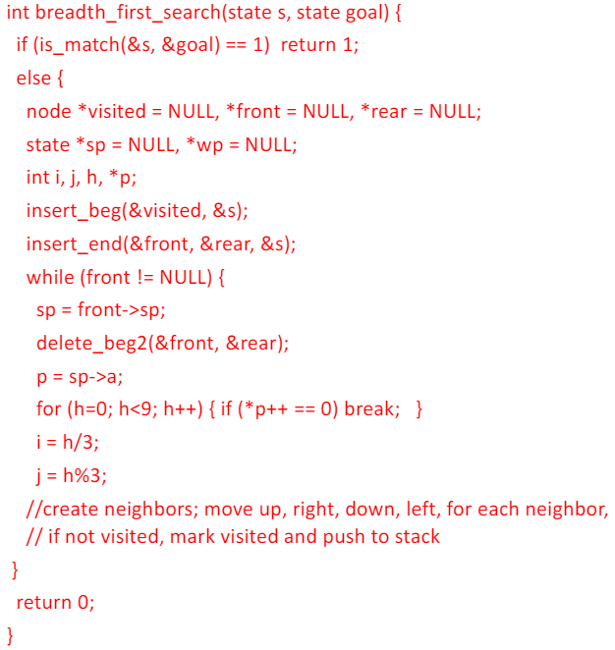

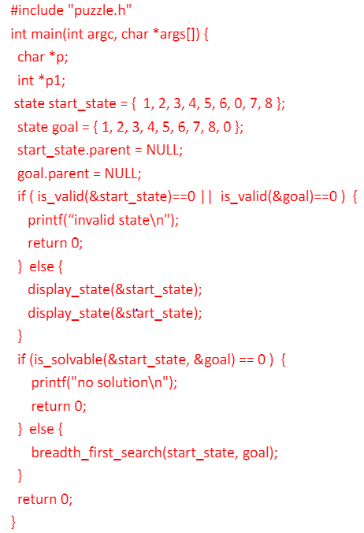

**Web graph and search engine**

* A search engine and index databases and search functions
* Index databases are created by crawling web graph
* Web graph consists of web pages as nodes, and hyperlinks as edges
* A crawler is a program, which traverses the web graph using a BFS algorithm, gets each web page by its URL, and gets keyword, and urls of linked pages
* Index database stores (url, keywords)
* Inverse index database stores (keyword, urls)
* Search function get a keyword argument and returns the list of urls containing the keyword, ordered by page ranking

**Object representation in computer graphics**

* What we see on computer screen is either images captured by camera, or computer generated
* Computer graphics is about the image generation by computer. It involves object modeling, representation (using data structure), and object rendering. For example, a simple cube object, consists of vertex, lines, and faces with colours. Rendering the cube is to draw the faces.
* For the convenience and effectiveness of creating and manipulating graphics objects, data (properties) and functions (methods) and bind together, and use the **class** template to define object types, and then build data structure to represent objects.
* C++ is an extension to C by adding the object-oriented programming features.

